**UNIX COMMANDS**

<http://javadecodedquestions.blogspot.com/>

**1) How to find hidden files in current directory?**  
  
   $ ls -lrta  
  
**2) How to find current running processes in unix server?**  
  
  $ ps -ef  
  
and if we want to find specific process we can use 'grep' with pipe  
  $ ps -ef | grep -i 'application'

For background use jobs

**4. How will you run a process in background? How will you bring that into foreground and how will you kill that process?**

For running a process in background use "&" in command line. For bringing it back in foreground use command "**fg jobid"**and for getting job id you use command "jobs", for killing that process find PID and use kill -9 PID command. This is indeed a good Unix Command interview questions because many of programmer not familiar with background process in UNIX.

Read more: <http://javarevisited.blogspot.com/2011/05/unix-command-interview-questions.html#ixzz38LEyEdck>

**3) How to find process which is taking maximum memory in server?**  
  $ top  
  top command tell us about cpu usage , process id and other details. below is output of top command

[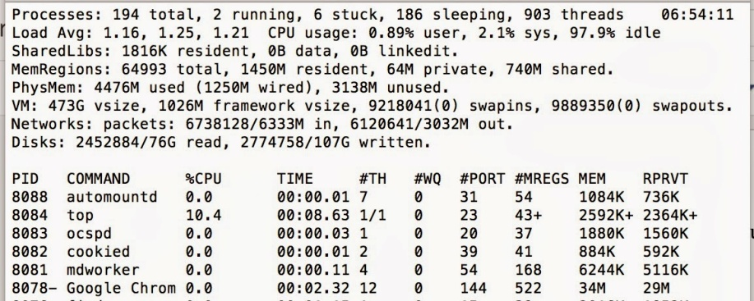](http://1.bp.blogspot.com/-2GGS0ySOVZ8/UtCdYOe_gbI/AAAAAAAAAOs/-ropKgCnGVI/s1600/top.tiff)

**4) How to find Exception in log files available in current directory and how to find number of occurrence?**  
      
   $ grep 'Exception' log1.txt | wc -l  
  
**5) find all files in current and subdirectories which contains 'log' name?**  
  
   $ find . -name 'log'  
    
  
**6)** **How do you access command line arguments from within a shell script?**

Arguments passed from the command line to a shell script can be accessed within the shell script by using a $ (dollar sign) immediately followed with the argument's numeric position on the command line.

**7) How to tails last 200 lines of any log fine?**  
    
    $ tail -200f filename.txt

**8) How to find remaining disk space in unix\linux server?**

    $ df -kl

df -kl

Filesystem   1024-blocks      Used Available Capacity  iused    ifree %iused  Mounted on

/dev/disk0s2   244277768 153679844  90341924    63% 38483959 22585481   63%   /

**9) How to make any script file executable?**

    $chmod 755 *.sh  
 **10) How to kill process in unix server?**  
    $ kill -9 #pid  
these #pid can be found using ps -ef command.  
  
**BASIC Unix Command List**

* **ls** --- lists your files  
  **ls -l** --- lists your files in 'long format', which contains lots of useful information, e.g. the exact size of the file, who owns the file and who has the right to look at it, and when it was last modified.  
  **ls -a**--- lists all files, including the ones whose filenames begin in a dot, which you do not always want to see.  
  There are many more options, for example to list files by size, by date, recursively etc.
* **more *filename*** --- shows the first part of a file, just as much as will fit on one screen. Just hit the space bar to see more or **q** to quit. You can use **/*pattern*** to search for a pattern.
* **mv *filename1 filename2*** --- moves a file (i.e. gives it a different name, or moves it into a different directory (see below)
* **cp *filename1 filename2*** --- copies a file
* **rm *filename*** --- removes a file. It is wise to use the option rm -i, which will ask you for confirmation before actually deleting anything. You can make this your default by making an alias in your .cshrc file.
* **diff *filename1 filename2*** --- compares files, and shows where they differ
* **wc *filename*** --- tells you how many lines, words, and characters there are in a file
* **chmod *options filename*** --- lets you change the read, write, and execute permissions on your files. The default is that only you can look at them and change them, but you may sometimes want to change these permissions. For example, **chmod o+r *filename*** will make the file readable for everyone, and **chmod o-r *filename*** will make it unreadable for others again. Note that for someone to be able to actually look at the file the directories it is in need to be at least executable.
* File Compression
  + **gzip *filename*** --- compresses files, so that they take up much less space. Usually text files compress to about half their original size, but it depends very much on the size of the file and the nature of the contents. There are other tools for this purpose, too (e.g. **compress**), but gzip usually gives the highest compression rate. Gzip produces files with the ending '.gz' appended to the original filename.
  + **gunzip *filename*** --- uncompresses files compressed by gzip.
  + **gzcat *filename*** --- lets you look at a gzipped file without actually having to gunzip it (same as **gunzip -c**). You can even print it directly, using **gzcat *filename* | lpr**

* [printing](https://www.blogger.com/blogger.g?blogID=4082727386380671161)
  + **lpr *filename*** --- print. Use the -P option to specify the printer name if you want to use a printer other than your default printer. For example, if you want to print double-sided, use 'lpr -Pvalkyr-d', or if you're at CSLI, you may want to use 'lpr -Pcord115-d'. See 'help printers' for more information about printers and their locations.

## DIRECTORIES

Directories, like folders on a Macintosh, are used to group files together in a hierarchical structure.

* **mkdir *dirname*** --- make a new directory
* **cd *dirname*** --- change directory. You basically 'go' to another directory, and you will see the files in that directory when you do 'ls'. You always start out in your 'home directory', and you can get back there by typing 'cd' without arguments. 'cd ..' will get you one [level up](javascript:void(0);) from your current position. You don't have to walk along step by step - you can make big leaps or avoid walking around by specifying pathnames.
* **pwd** --- tells you where you currently are.

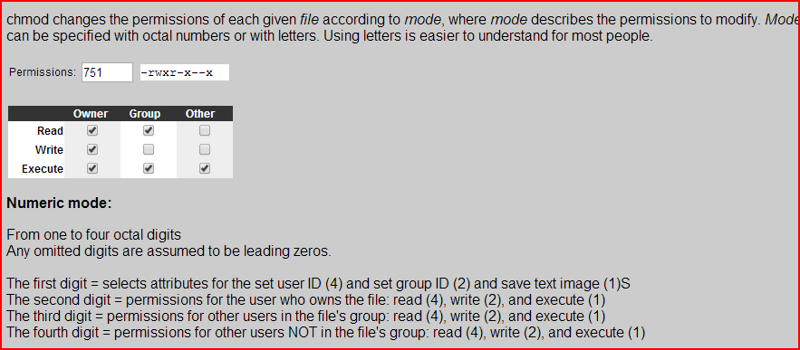

Grep command:

<http://www.thegeekstuff.com/2009/03/15-practical-unix-grep-command-examples/>

VI Commands

<http://www.lagmonster.org/docs/vi.html>

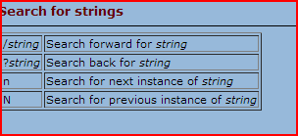

Replace a word in UNIX.

*The substitute command can be used to replace all occurrences of a* [*word*](http://vimdoc.sourceforge.net/htmldoc/motion.html#word) *with*

*another* [*word*](http://vimdoc.sourceforge.net/htmldoc/motion.html#word)*:*

***:%s/four/4/g***

*The "*[*%*](http://vimdoc.sourceforge.net/htmldoc/motion.html#%)*" range means to replace in all lines. The "*[*g*](http://vimdoc.sourceforge.net/htmldoc/index.html#g)*" flag at the end causes*

*all words in a line to be replaced.*

*This will not* [*do*](http://vimdoc.sourceforge.net/htmldoc/diff.html#do) *the right thing if your file also contains "thirtyfour".*

*It would be replaced with "thirty4". To avoid this, use the "\<" item to*

*match the start of a* [*word*](http://vimdoc.sourceforge.net/htmldoc/motion.html#word)*:*

***:%s/\<four/4/g***

*Obviously, this still goes wrong on "fourty". Use "\>" to match the end of a*

[*word*](http://vimdoc.sourceforge.net/htmldoc/motion.html#word)*:*

***:%s/\<four\>/4/g***

*If you are programming, you might want to replace "four" in comments, but not*

*in the code. Since this is difficult to specify, add the "*[*c*](http://vimdoc.sourceforge.net/htmldoc/change.html#c)*" flag to have the*

*substitute command prompt you for each replacement:*

***:%s/\<four\>/4/gc***

<http://javarevisited.blogspot.com/2011/05/unix-command-interview-questions.html>

### Beginners UNIX Interview Questions Answers

**1. Write command to list all the links from a directory?**

In this UNIX command interview questions interviewer is generally checking whether user knows basic use of "ls" "grep" and regular expression etc

You can write command like:

ls -lrt | grep "^l"

**2. Create a read-only file in your home directory?**

This is a simple UNIX command interview questions where you need to create a file and change its parameter to read-only by using chmod command you can also change your umask to create read only file.

touch file

chmod 400 file

read more about [**file and directory permission in unix and linux**](http://javarevisited.blogspot.com/2011/11/file-permissions-in-unix-linux-example.html) here.

**3. How will you find which operating system your system is running on in UNIX?**

By using command **"uname -a"**in UNIX

**4. How will you run a process in background? How will you bring that into foreground and how will you kill that process?**

For running a process in background use "&" in command line. For bringing it back in foreground use command "**fg jobid"**and for getting job id you use command "jobs", for killing that process find PID and use kill -9 PID command. This is indeed a good Unix Command interview questions because many of programmer not familiar with background process in UNIX.

**5. How do you know if a remote host is alive or not?**

You can check these by using either **ping** or **telnet** command in UNIX. This question is most asked in various Unix command Interview because its most basic networking test anybody wants to do it.

**6. How do you see command line history in UNIX?**

Very useful indeed, use history command along with**[grep command in unix](http://javarevisited.blogspot.com/2011/06/10-examples-of-grep-command-in-unix-and.html)**to find any relevant command you have already executed. Purpose of this Unix Command Interview Questions is probably to check how familiar candidate is from available tools in UNIX operation system.

**7. How do you copy file from one host to other?**

Many options but you can say by using "**scp**" command. You can also use **rsync** command to answer this UNIX interview question or even **sftp** would be ok.

**8. How do you find which process is taking how much CPU?**

By using "top" command in UNIX, there could be multiple follow-up UNIX command interview questions based upon response of this because “TOP” command has various interactive options to [sort](http://javarevisited.blogspot.com/2011/08/unix-sort-command-example-tutorial.html)result based upon various parameter.

**9. How do you check how much space left in current drive ?**

By using **"df"** command in UNIX. For example **"df -h ."** will list how full your current drive is. This is part of anyone day to day activity so I think this Unix Interview question will be to check anyone who claims to working in UNIX but not really working on it.

**10. What is the difference between Swapping and Paging?**

Swapping:

Whole process is moved from the swap device to the main memory for execution. Process size must be less than or equal to the available main memory. It is easier to implementation and overhead to the system. Swapping systems does not handle the memory more flexibly as compared to the paging systems.

Paging:

Only the required memory pages are moved to main memory from the swap device for execution. Process size does not matter. Gives the concept of the virtual memory. It provides greater flexibility in mapping the virtual address space into the physical memory of the machine. Allows more number of processes to fit in the main memory simultaneously. Allows the greater process size than the available physical memory. Demand paging systems handle the memory more flexibly.

### Intermediate UNIX Interview Questions Answers

**1. What is difference between ps -ef and ps -auxwww?**

[](http://javarevisited.blogspot.com/2011/03/10-find-command-in-unix-examples-basic.html)This is indeed a good Unix Interview Command Question and I have faced this issue while ago where one culprit process was not visible by execute **ps –ef** command and we are wondering which process is holding the file.

ps -ef will omit process with very long command line while ps -auxwww will list those process as well.

**2. How do you find how many cpu are in your system and there details?**

By looking into file /etc/cpuinfo for example you can use below command:

**cat /proc/cpuinfo**

**3. What is difference between HardLink and SoftLink in UNIX?**

I have discussed this Unix Command Interview questions  in my blog post [difference between Soft link and Hard link in Unix](http://javarevisited.blogspot.com/2011/04/symbolic-link-or-symlink-in-unix-linux.html)

**4. What is Zombie process in UNIX? How do you find Zombie process in UNIX?**

When a program forks and the child finishes before the parent, the kernel still keeps some of its information about the child in case the parent might need it - for example, the parent may need to check the child's exit status. To be able to get this information, the parent calls 'wait()'; In the interval between the child terminating and the parent calling 'wait()', the child is said to be a 'zombie' (If you do 'ps', the child will have a 'Z' in its status field to indicate this.)

**Zombie : The process is dead but have not been removed from the process table.**

**5. What is "chmod" command? What do you understand by this line “r-- -w- --x?**

**6. There is a file some where in your system which contains word "UnixCommandInterviewQuestions” How will find that file in Unix?**

By using find command in UNIX for details see here [10 example of using find command in Unix](http://javarevisited.blogspot.com/2011/03/10-find-command-in-unix-examples-basic.html)

**7. In a file word UNIX is appearing many times? How will you count number?**

grep -c "Unix" filename

**8. How do you set environment variable which will be accessible form sub shell?**

By using **export**   for example export count=1 will be available on all sub shell.

**9. How do you check if a particular process is listening on a particular port on remote host?**

By using telnet command for example “telnet hostname port”, if it able to successfully connect then some process is listening on that port. To read more about telnet read [networking command in UNIX](http://javarevisited.blogspot.com/2010/10/basic-networking-commands-in-linuxunix.html)

**10. How do you find whether your system is 32 bit or 64 bit ?**

Either by using **"uname -a"** command or by using "**arch**" command.

### Advanced UNIX Interview Questions and Answers

**1. How do you find which processes are using a particular file?**

By using **lsof** **command** in UNIX. It wills list down PID of all the process which is using a particular file.

**2. How do you find which remote hosts are connecting to your host on a particular port say 10123?**

By using **netstat command** execute netstat -a | grep "port" and it will list the entire host which is connected to this host on port 10123.

**3. What is nohup in UNIX?**

**4. What is ephemeral port in UNIX?**

Ephemeral ports are port used by Operating system for client sockets. There is a specific range on which OS can open any port specified by ephemeral port range.

**5. If one process is inserting data into your MySQL database? How will you check how many rows inserted into every second?**

Purpose of this Unix Command Interview is asking about **"watch" command** in UNIX which is repeatedly execute command provided with specified delay.

**6. There is a file Unix_Test.txt which contains words Unix, how will you replace all Unix to UNIX?**

You can answer this Unix Command Interview question by using SED command in UNIX for example you can execute **sed s/Unix/UNIX/g fileName.**

**7. You have a tab separated file which contains Name, Address and Phone Number, list down all Phone Number without there name and Addresses?**

To answer this Unix Command Interview question you can either you AWK or CUT command here. CUT use tab as default separator so you can use

**cut -f3 filename.**

**8. Your application home directory is full? How will you find which directory is taking how much space?**

By using disk usage (DU) command in Unix for example du**–sh . | grep G**  will list down all the directory which has GIGS in Size.

**9. How do you find for how many days your Server is up?**

By using **uptime** command in UNIX

**10. You have an IP address in your network how will you find hostname and vice versa?**

This is a standard UNIX command interview question asked by everybody and I guess everybody knows its answer as well. By using **nslookup** command in UNIX, you can read more about [**Convert IP Address to hostname in Unix**](http://javarevisited.blogspot.com/2011/09/find-hostname-from-ip-address-to.html) here.

I hope this ***UNIX command interview questions and answers*** would be useful for quick glance before going for any UNIX or Java job interview. Please share any interesting UNIX command interview you have come across and I will add into this list. If you are going for any Unix interview on brokerage firm or stock trading company or any Investment bank you can have a quick look here, though most of questions you might already know but its good to review it. if you like this you can see my other [unix command tutorial for beginners](http://javarevisited.blogspot.com/2011/04/unix-commands-tutorial-and-tips-for.html) as well

Read more: <http://javarevisited.blogspot.com/2011/05/unix-command-interview-questions.html#ixzz38LD9d4Xa>

Change file permissions:

<https://kb.iu.edu/d/abdb>

**Symbolic method**

The first and probably easiest way is the relative (or symbolic) method, which lets you specify access classes and types with single letter abbreviations. A chmod command with this form of syntax consists of at least three parts from the following lists:

| **Access Class** | **Operator** | **Access Type** |
| --- | --- | --- |
| u (user) | + (add access) | r (read) |
| g (group) | - (remove access) | w (write) |
| o (other) | = (set exact access) | x (execute) |
| a (all: u, g, and o) |  |  |

For example, to add permission for everyone to read a file in the current directory named myfile, at the Unix prompt, you would enter:

chmod a+r myfile

The a stands for "all", the + for "add", and the r for "read".

**Difference between grep and find command**

grep is used to search the content (word or phrase) within the file or files from directories where FIND command usually used to search the files from the disk

<http://javarevisited.blogspot.com/2011/06/10-examples-of-grep-command-in-unix-and.html>

**10 examples of grep command in UNIX and Linux**

$ **grep** UNIX example.txt  
UNIX operating system  
UNIX and Linux operating system

Now to exclude all lines which contains Linux we will apply another grep command in this output with option -v to exclude matching word as shown in below grep command :

$ **grep** UNIX example.txt  **|** **grep** -v Linux  
UNIX operating system

Read more: <http://javarevisited.blogspot.com/2011/06/10-examples-of-grep-command-in-unix-and.html#ixzz3CghCEMGH>

**Grep command Example 2:**   
If you want to count of a particular word in log file you can use grep -c option to count the word. Below example of command will print how many times word "Error" has appeared in logfile.txt.

**grep** -c "Error" logfile.txt

If we apply this grep command on our example file to find how many lines contains  word e.g. UNIX has occurred in the file :

$**grep**-c UNIX example.txt

2

Read more: <http://javarevisited.blogspot.com/2011/06/10-examples-of-grep-command-in-unix-and.html#ixzz3Cghns0kF>

**grep -C 2 'hello' \***

Prints two lines of context around each matching line.

Read more: <http://javarevisited.blogspot.com/2011/06/10-examples-of-grep-command-in-unix-and.html#ixzz3Cghx0ylu>

**1. Write command to list all the links from a directory?**

In this UNIX command interview questions interviewer is generally checking whether user knows basic use of "ls" "grep" and regular expression etc

You can write command like:

ls -lrt | grep "^l"

Read more: <http://javarevisited.blogspot.com/2011/05/unix-command-interview-questions.html#ixzz3CgjPmfRX>